UML:

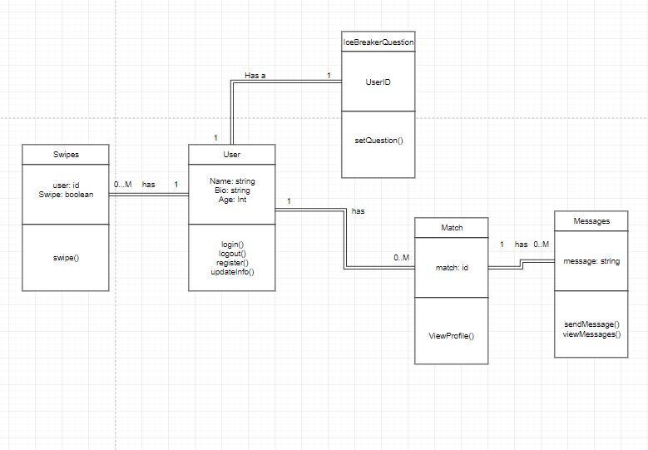

The description of the architecture and the justification of the chosen architecture.

The sprout application will be designed using the following software architecture.

|  |  |  |  |
| --- | --- | --- | --- |
| **What** | **What is does** | **Why** | **Version** |
| Node.js | Node.js is backbone for the entire application of Sprout. Node.js is used in both the frontend and backend. Node.js is used in combination with Expo and React Native to quickly write code for both Android and IOS devices. | Several team members are familiar already familiar with Node.js and it’s abilities. Node.js is a non-blocking language which will result in a faster completed application as opposed to other traditional approaches. With the use of Expo and React development time has essentially been cut in half but only having one code base for all target platforms. | 10.15.3 |
| MySQL | This is the database for the application and where all of the user data will be kept. | MySQL was selected because the team members were familiar with the technology and because a relational database technology was needed for the application as opposed to a non relational database. | 10.1.29 |
| Ubuntu Linux | This is where the server for the application lives. All user data will be stored here. | It is a quick environment to get setup and running. Both Node.js and MySQL can be easily setup within this software environment to run. | 18.04.2 |